**Satellite Imagery (Hard)**

**We traced a hacker to the location shown in this satellite photo. Can you find where it is?**

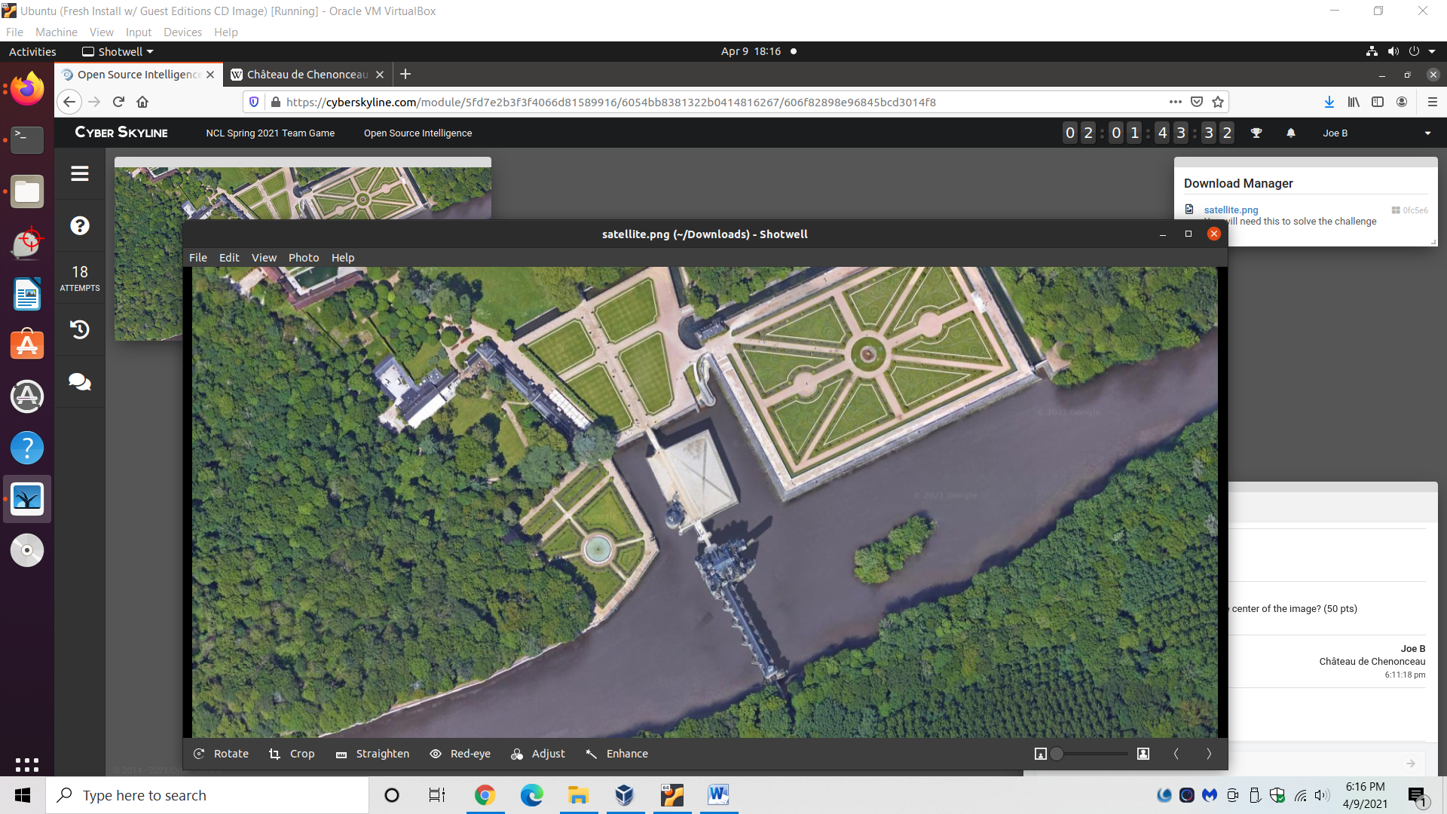

**What is the country of this location? (25 pts)**

* Reverse image search the satellite image.
  + Note the “Google 2021” watermark on the image; this hints that the image is online somewhere.
* Browse around to find it’s the Château de Chenonceau in France.
  + Wikipedia on the estate: https://en.wikipedia.org/wiki/Ch%C3%A2teau_de_Chenonceau

Answer: France

**What is the name of the larger building in the center of the image? (50 pts)**

Answer: Château de Chenonceau